TARİH: 11.10.2019
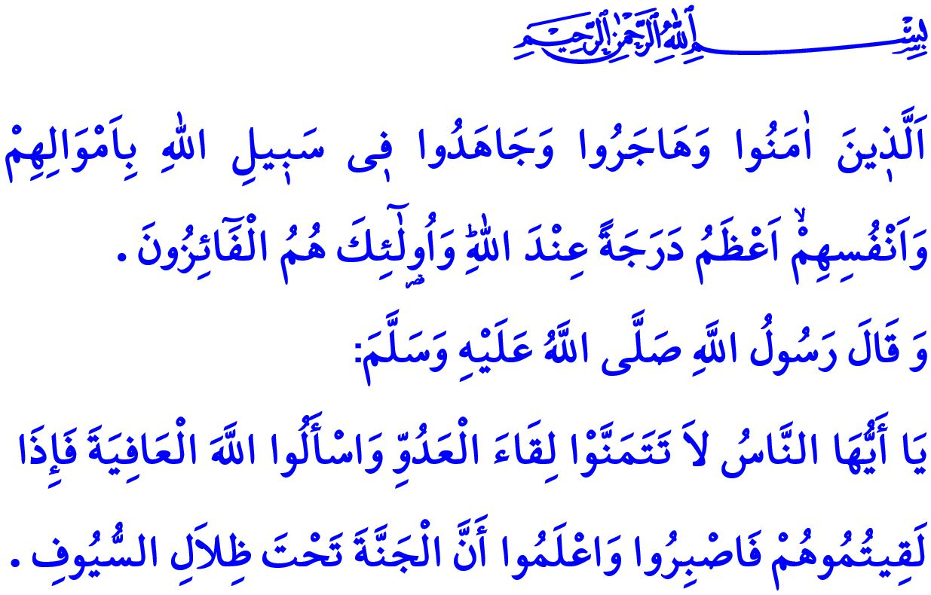
TODAY IS THE DAY OF UNITY AND SOLIDARITY
Honorable Muslims!
In the verse I have just recited, Allah the Almighty (swt) states, “The ones who have believed, emigrated and striven in the cause of Allah with their wealth and their lives are greater in rank in the sight of Allah. It is those who are the attainers of success.”
In the hadith I have just recited, the Prophet Muhammad (saw) says, “O people! Do not desire an encounter with the enemy. Pray to Allah to grant you security. But when you encounter the enemy, be patient and firm. Know this well that the Heaven is under the shades of swords.”
Dear Believers!
We as the Turkish nation have overcome numerous challenges. Those who want to remove us from the stage of the history have never given up on their cause. However, those who set their eyes on our homeland, every inch of which is watered by the blood of our noble martyrs, and who aim to scatter our nation are doomed to lose today, too, just as in the past. For we have that irrepressible power to make us victorious against our enemies. The source of our irrepressible power is our unshakable faith in Allah, our strong attachment to the sublime religion of Islam, and our deep love for our homeland, national flag, and independence.
Dear Muslims!
Muslims cannot approve and tolerate when the sacred and inviolable values of Islam are aimed to be trodden. They rather honorably strive to vanish all kinds of evil and ensure that peace prevails. This is how our heroic nation have throughout its history fought in this cause. All our efforts have been to ensure a peaceful, safe, and secure environment. We have not set an eye on anybody's homeland; however, we have put forth our chests full of and firm on faith as a shield against whosoever has set an eye on our homeland. We have never let our enemies set foot on our homeland, never let them bring down our national flag, and never let them stop our adhans from being echoed in our skies.

Dear Believers!
Unfortunately, the world today was turned into a place full of dark and evil traps. Those who claimed to bring so-called independence to some places have rather invaded those places. Innocent people have been forced to leave their homes. The very young and tender corpses of children hit the shores. Those who plan to dig pits of fire in all around the Islamic world have used weapons of sedition, terrorism, and betrayal to cause brothers to hit one another. Using various plots, plans, tricks and traps, they have targeted our existence and future survival, as well as our freedom and future. They have attempted to bring us, our noble nation to have been the flagbearer of the Muslim ummah for hundreds of years, to our knees.
Honorable Believers!
Notwithstanding all these challenges, we, together as our men and women, young and old people, in short with every fellow national, will fight for diminishing the evil and for establishing the good on earth. Our noble nation will overturn all the dark plots through their insight and foresight. Just as in the past, today, too, our nation will continue to be the remedy for the remediless people, be there for those people who has nobody by their side, and be the hope and safe haven for the victimized and the refugees.
If need be, we put up with hunger and thirst; however, never do we make any concessions on our freedom, independence, honor, and grace. We make any sacrifice and stand straight against any attack against our homeland, our sacred values, our unity and solidarity. Never do we forsake an inch of this heavenly homeland and let the enemy have it.
Then, let us not give any opportunity to those who aim to set us as nation against each other. Let us continue to interlock our hearts with being brothers and sisters in faith. Let us be awake and alert against those who fuel terrorism, sedition, and discord. Let us avoid any word or action that might damage our resolution, affection for each other, unity, and harmony.
Come, let us open our hands and pray to Allah the Almighty (swt) in this hour of this blessed Friday when prayers are accepted:
O Lord! Do not let them succeed who target our grace and honor, independence and future survival and who set their eyes on our existence and homeland!
Help our heroic army mobilized for our nation's security and peace, and for the region's peace and prosperity!
Protect each and every soldier of our army against all dangers and traps! With Your Might and Help, let us come through as victorious in our cause to vanish sedition and terrorism!

Tawbah, 9/20.
Bukhari, Jihad, 112; Muslim, Jihad wa Siyar, 20. General Directorate of Religious Services

